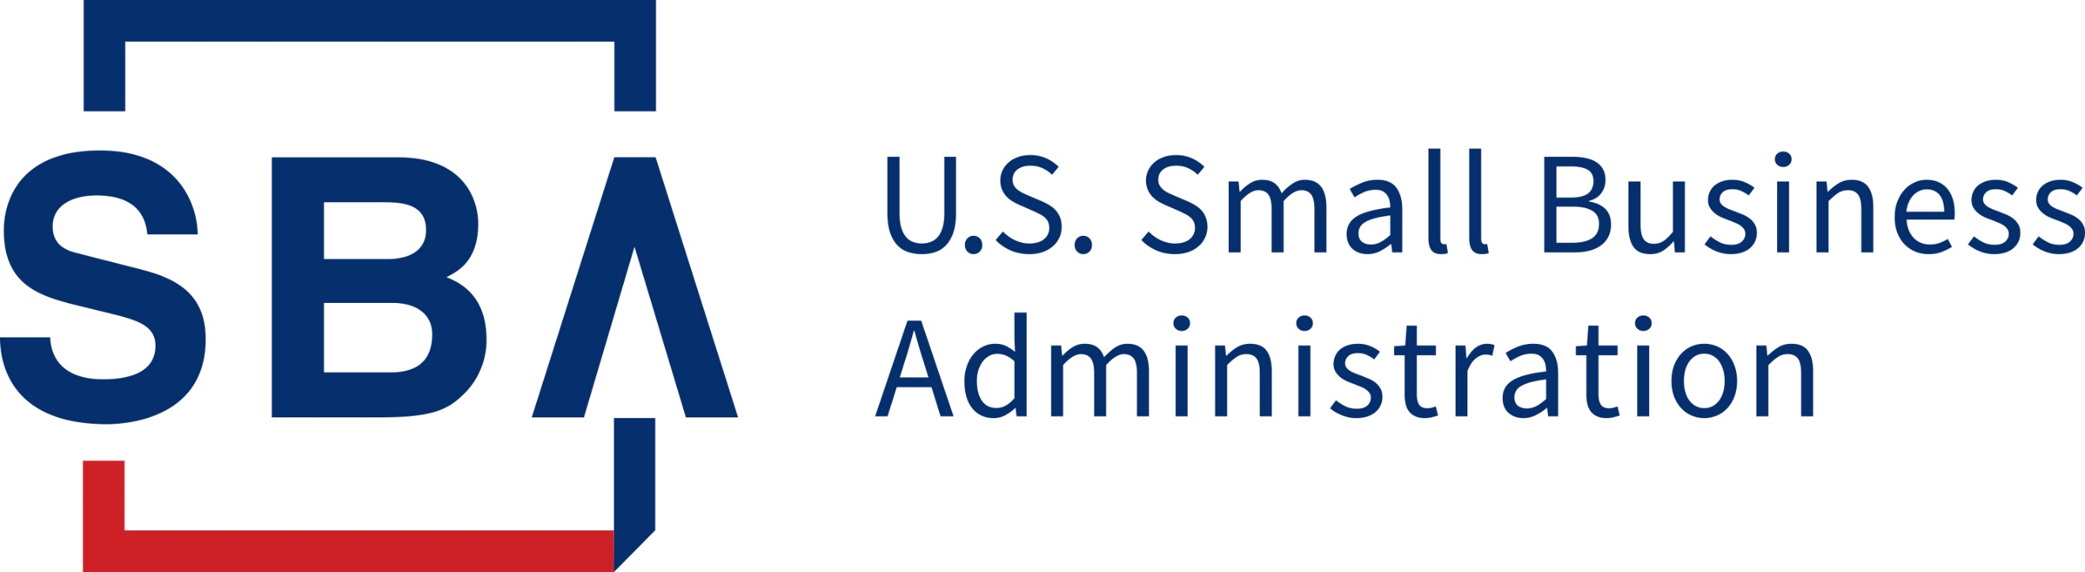
COVID EIDL INORMATION

From the SBA Northern Ohio District Office

As of Friday, August 6, 2021
Product | The COVID Economic Injury Disaster Loan (COVID EIDL) is a loan directly from SBA that must be repaid. Low-interest, fixed-rate, long-term loan to help overcome the effects of the pandemic by providing working capital to meet operating expenses
Uses of Proceeds | Normal operating expenses and working capital
Maximum Loan Amount | $500,000
Loan Term | 30 years
Interest Rate | Businesses: 3.75% fixed  Private nonprofit organizations: 2.75% fixed
Payment Deferment | Payments can be deferred for 24 months. No penalty for prepayment.
Fees | No fees if applying directly through SBA
Collateral | Required for loans greater than $25,000
Personal Guaranty | Required for loans greater than $200,000
Apply for a Loan | Complete your application online via sba.gov/eidl
Apply for an Increase | Complete your application online via sba.gov/eidl

What is a COVID EIDL loan?
COVID EIDL loans are distinct and different from regular Disaster Loan Program loans. “COVID EIDL” stands for COVID-19 Economic Injury Disaster Loan. On March 27, 2020, in response to the COVID-19 pandemic, SBA was given the authority to make low-interest fixed-rate long-term COVID EIDL loans to help small businesses and other entities overcome the effects of the pandemic by providing borrowers with working capital to meet ordinary and necessary operating expenses.

What are the loan terms?
- Loan or Grant: A COVID EIDL loan is a loan that must be repaid. Unlike the Paycheck Protection Program, a COVID EIDL loan is not forgivable.
- Interest Rate and Term:
  - Businesses: 3.75% fixed for 30 years,
  - Private nonprofit organizations: 2.75% fixed for 30 years
  - Payment Deferral: The loan term is 30 years; payments are deferred for the first 24 months (during which interest will accrue), and payments of principal and interest are made over the remaining years. You may make prepayments at any time without penalty.
- Collateral:
  - $0 - $25,000: No collateral required
  - $25,001 - $500,000: Security agreement (UCC-1) required on business assets (no lien on real estate unless as an accommodation to the applicant)
- Personal Guaranty:
  - $0 - $200,000 No personal guaranty required
  - $200,001 - $500,000 All loans require a full personal guaranty from all individuals or entities owning 20% or more of the applicant business. If no single owner owns 20% or more, then at least one individual or entity must provide a full guarantee
- Underwriting: Repayment ability of for-profit businesses will be determined by the owner’s credit score (minimum of 570)
  - An acceptable credit score will satisfy the underwriting requirement for repayment ability
  - Applicant is not eligible if listed on a Federal Do Not Pay list

How is the loan amount calculated?
The eligible loan amount is based on 2019 IRS tax information. The calculation is Total gross receipts less COGS (cost of goods sold) x 2 (24 months) For example: $160,000 (rev) less $100,000 (COGS) = $60,000 annual margin x 2 = $120,000 maximum eligible loan amount.
- Non-Profit and Agricultural entities are eligible for the lesser of $500,000 or 24 months of operating expenses.
- Rental properties are eligible for the lesser of up to 24 months of rental losses or $500,000

Is the maximum loan amount $150K, $500K, or $2M?
The maximum loan amount is $500,000. It was previously $150,000 but was raised in March, 2021. If you previously applied for a COVID EIDL loan and received the maximum loan amount under the $150,000 cap, you can apply for a loan increase.

If I own multiple businesses, can I receive more than one COVID EIDL loan?
Yes, separate applications should be submitted for each entity with their corresponding EIN, however the combined loan amounts of the affiliated/related applications cannot exceed the legislative limit of $2,000,000.

Are franchises eligible for COVID EIDL loans?
Franchises are eligible provided the applicant's brand is listed in SBA's Franchise Directory. If a Franchise is listed in the directory with Notes stating they are eligible for PPP loan only, they are ineligible for the COVID EIDL loan.

Does interest accrue during the deferment period?
Yes

What can I use the loan proceeds for?
Borrowers may use COVID EIDL working capital loan proceeds to make regular payments for operating expenses and to pay business debt incurred at any time (including business credit card debt), payroll, rent/mortgage, utilities, and other ordinary business expenses. You may not use the funds to expand your business.

Can gig workers (ex. Uber/Lyft drivers) use a COVID EIDL loan or EIDL Advance Grant to pay themselves their pre-pandemic level of earnings?
Yes

Can the COVID EIDL loan be forgiven?
No

I have multiple businesses. Can I submit multiple COVID-19 EIDL applications?
Yes, you'd apply separately for each business with the corresponding EIN Number. However, be aware that businesses or individuals that submit multiple applications for COVID EIDL relief, those applications will be reviewed and matched with other applications using various data points such as legal name, email addresses, SSN/EIN, etc. If your application was flagged as a duplicate and you believe that was done in error, contact PDC.Reconsideration@sba.gov indicating that is the case and the file will be reviewed.

###

